**What is a computer program?**

A computer program is a set of instructions that a computer follows to complete a task. “Coding”, or “programming”, means writing the step-by-step instructions that tell the computer what to do.

**Computer programs are everywhere**

|  |  |  |
| --- | --- | --- |
| file:///var/folders/t5/vc3zydkn33x0jmy8pbncrlnr0000gn/T/com.microsoft.Word/screenshot.png  Mobile phones  Programs allow you to make a  phone call or send text messages.  When you search for a contact,  a program finds the correct  phone number. | file:///var/folders/t5/vc3zydkn33x0jmy8pbncrlnr0000gn/T/com.microsoft.Word/screenshot.png  △ Computer software  Everything a computer does, from  browsing the Internet to writing  documents or playing music, works  because of code written by a  computer programmer. | file:///var/folders/t5/vc3zydkn33x0jmy8pbncrlnr0000gn/T/com.microsoft.Word/screenshot.png  △ Washing machines  Washing machines are programmed  to follow different cycles. Computer  code controls how hot the water is  and how long the wash takes. |
| file:///var/folders/t5/vc3zydkn33x0jmy8pbncrlnr0000gn/T/com.microsoft.Word/screenshot.png  ◁ Games  Consoles are just another type of  computer, and all the games that  run on them are programs. All the  graphics, sounds, and controls  are written in computer code. | file:///var/folders/t5/vc3zydkn33x0jmy8pbncrlnr0000gn/T/com.microsoft.Word/screenshot.png  ▷ Cars  In some cars, computer  programs monitor the  speed, temperature,  and amount of fuel in  the tank. Computer  programs can even help  control the brakes  to keep people safe. |  |

**How computer programs work**

Computers might seem very smart, but they are actually just boxes that follow instructions very quickly and accurately. As intelligent humans, we can get them to carry out different tasks by writing programs, or lists of instructions.

**Computers can’t think**

A computer won’t do anything by itself. It’s up to the computer programmer to give it instructions.



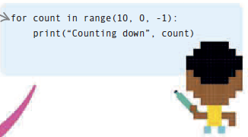

**Write a Program**

You can tell a computer what to do by writing a set of very detailed instructions called a program. Each instruction has to be small enough that the computer can understand it. If the instructions are incorrect, the computer won’t behave the way you want it to.

**Programming languages** Computers can only followinstructions in a language theyunderstand. It’s up to theprogrammer to choose whichlanguage is best for the task.

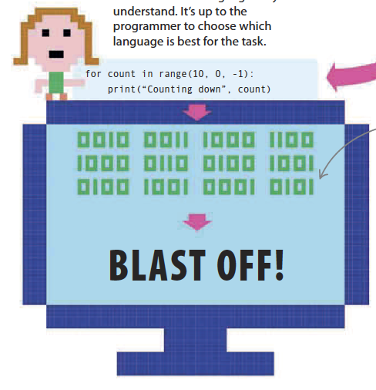

Think like a computer

A programmer must learn to think like a computer. All tasks must be broken down into small chunks so they are easy to follow, and impossible to get wrong.

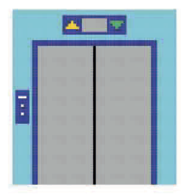

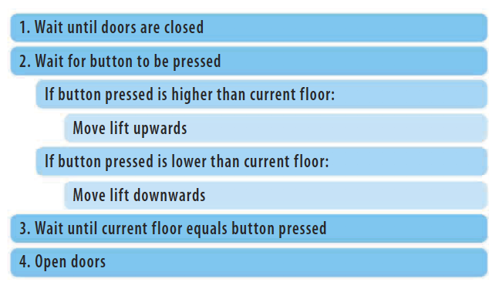

For the lift to work correctly and safely, every step has to be precise, clear, and cover every possibility. The programmers have to make sure they create

Becoming a coder

Coders are the people who write the programs behind everything we see and do on a computer. You can create your own programs by learning a programming language.

**Programming languages**

There are a huge range of programming languages to choose from. Each one can be used for different tasks. Here are some of the most popular languages and what they are often used for:

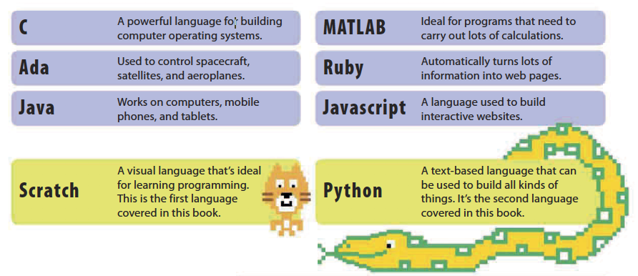

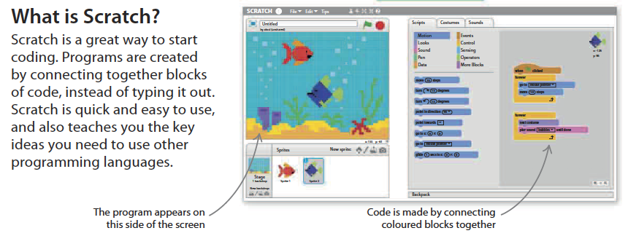

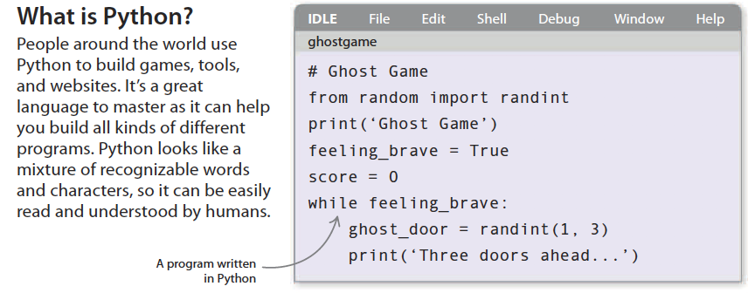

**Getting started**

It’s time to start programming. All you need is a computer with an Internet connection.

